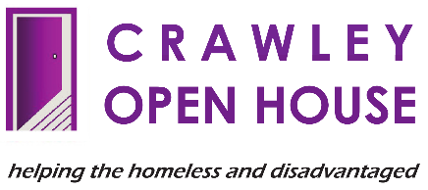 |  | PERSON SPECIFICATION –  TEAM AROUND THE  PERSON (TAP) WORKER

CRITERIA TO BE EVIDENCED

QUALIFICATIONS

DESIRABLE:
- A relevant qualification in mental health, social work, health care, substance or alcohol dependency, etc.

EXPERIENCE

ESSENTIAL:
- Experience of working as part of a multi-disciplinary team providing support to people experiencing multiple disadvantage.

KNOWLEDGE AND UNDERSTANDING

ESSENTIAL:
- An understanding of homelessness, alcohol misuse, substance misuse, mental health, criminal justice and domestic abuse and how these issues impact on the wellbeing of the vulnerable and disadvantaged.

- Knowledge of the roles of external agencies, e.g., Addaction, Health Services, Social Services, Probation, Police, Council, etc., and how they can be accessed to provide support for clients.

- Understanding of professional boundaries and the ability to apply these in a community setting/lone working.

DESIRABLE:
- Experience of working with therapeutic approaches, e.g. brief intervention, behavioural models, etc.

- Knowledge of housing and support needs of homeless people.

- An understanding of housing and welfare benefits.

SKILLS AND ABILITIES

ESSENTIAL:
- Good literacy and numeracy skills.

- An ability to understand and implement professional personal and team boundaries.

- Excellent communication and influencing skills. (Verbal and written.)

- Good organisational and time management skills.

- Ability and commitment to building relationships with individuals to rebuild trust and hope.

4. SKILLS AND ABILITIES
DESIRABLE:
- An ability to implement strategies for coping with aggression and minimising risk.
2. Good IT skills.

5. PERSONAL QUALITIES
ESSENTIAL:
- A commitment to the practical application of the Crawley Open House Equal Opportunities Policy.

- Able to deal with an opposing point of view, exercising tact, sensitivity and diplomacy and the ability to listen to others.
- A commitment to developing and maintaining a high level of service to colleagues, clients and professional partners.
- A positive, self-motivated and enthusiastic attitude to work.
- Desire and willingness to make a positive contribution to a team.
- The capacity to handle pressure; to be adaptable to changing or conflicting demands and the ability to organise workload efficiently, balancing face-to-face work with paperwork.
- The ability to identify solutions and implement them.
- The ability to actively contribute and listen to ideas and suggestions that improve the quality of service.
- To have a positive attitude to training and professional development.

